What is in these cards with bleed?

This folder contains the Scratch Cards, status mid-2020, from <https://github.com/LLK/scratch-resources/tree/master/resources/source/cards/Powerpoint-files> adapted in two ways:

1. All Scratch Cards have been updated to be more easily be translatable, because the size of the text blocks is larger, the indentation and alignment has been fixed and also the low resolution icons in the wrong colour have been replaced. See for details the parallel folder *English Scratch Cards easier to translate*.
2. A date has been added on right hand side. You can replace yyyymmdd into the date that you made the translation. The colour has been chosen such that it is visible, but not disturbing.
3. The cards have been enlarged, i.e. the drawing canvas has been extended with 4 mm left and right and proportionally top and bottom. This is the bleed to allow the printshop to cut the cards to the target size.

This is the way it was done in PowerPoint

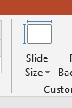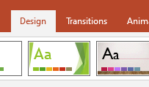

Select the Design tab Select *Slide Size*

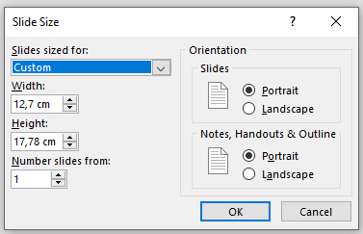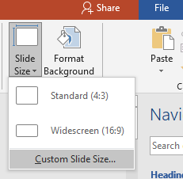

And then *Custom Slide Size* The current size is displayed.

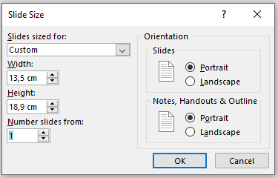

Then fill in the new size: 135 mm wide, 189 mm high and click *OK*

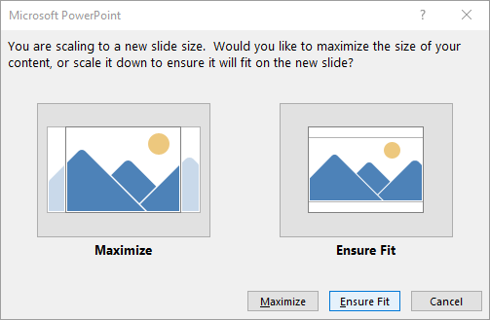

On this screen, choose *Ensure Fit*.

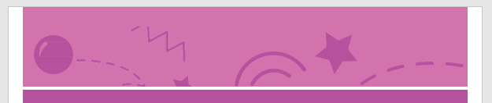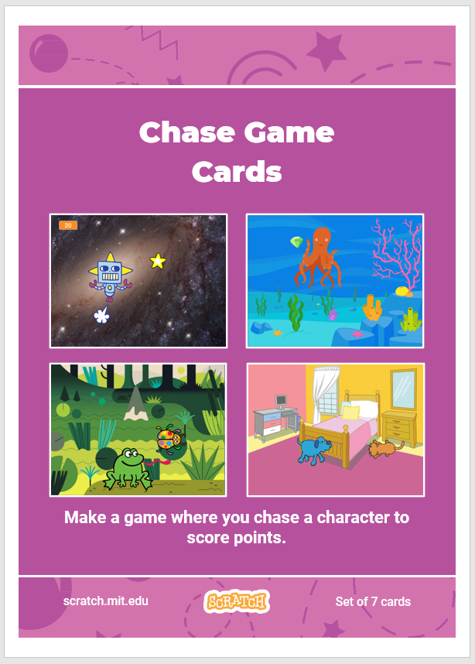The drawing canvas is now enlarged as you can see by the white margin around.

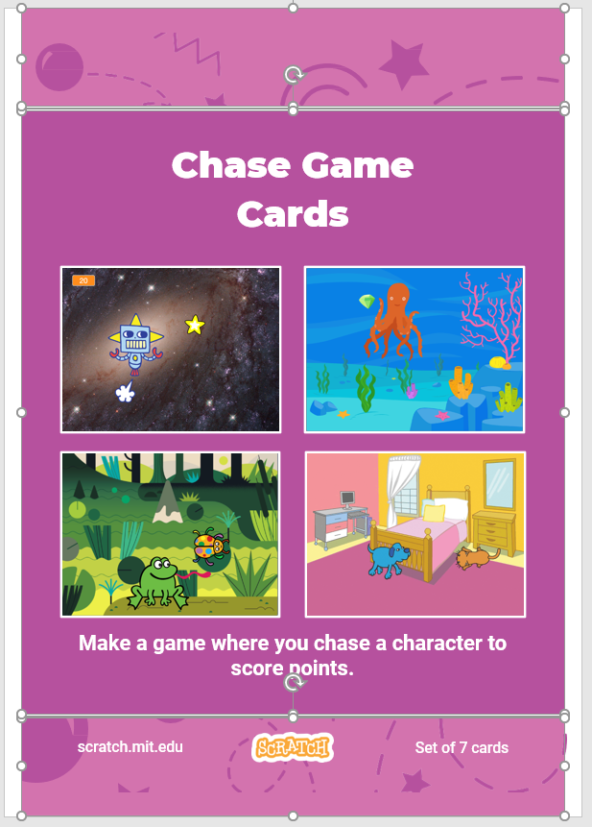

Click the top bar and extend it to the top.

Click the bottom bar and extend it to the bottom.

The illustrations contained in those bars are not extended, although that would have been better for the end result, but no way was seen to do this.

Click one of the white bars and with holding the SHIFT key down click the other one and then the purple areas. Then with one of the handles stretch it to left and right.

This must be done for each page separately.